<https://leetcode.com/problems/kth-smallest-element-in-a-bst/submissions/1569129410/>

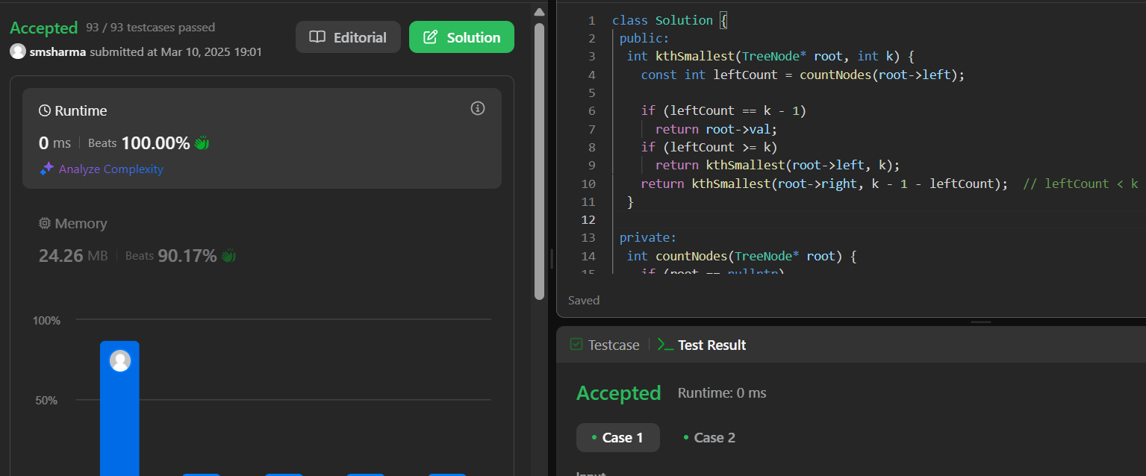

<https://leetcode.com/problems/populating-next-right-pointers-in-each-node/submissions/1569128989/>

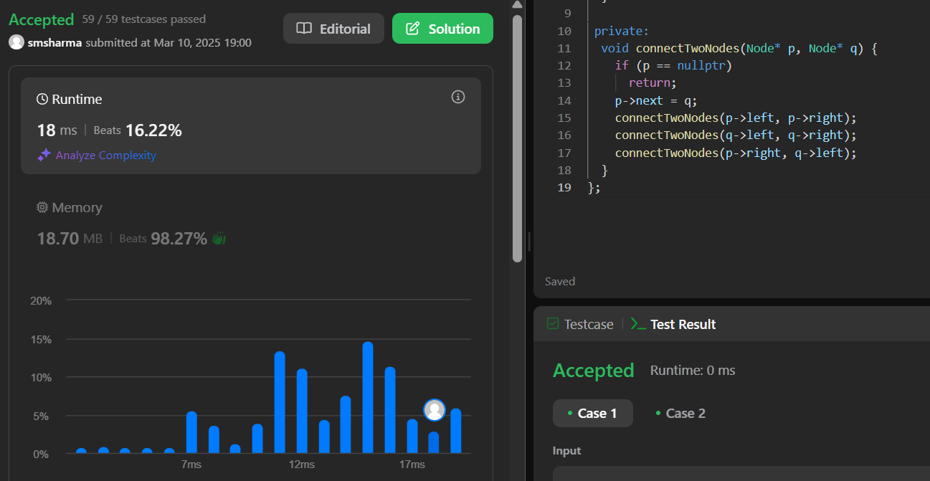

<https://leetcode.com/problems/sum-of-left-leaves/submissions/1569128320/>

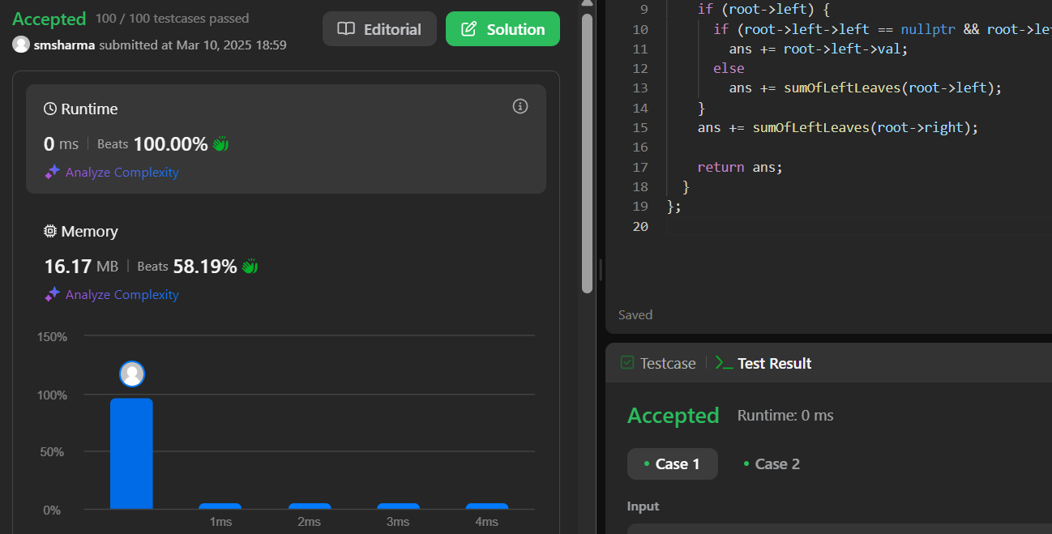

<https://leetcode.com/problems/validate-binary-search-tree/submissions/1569127757/>

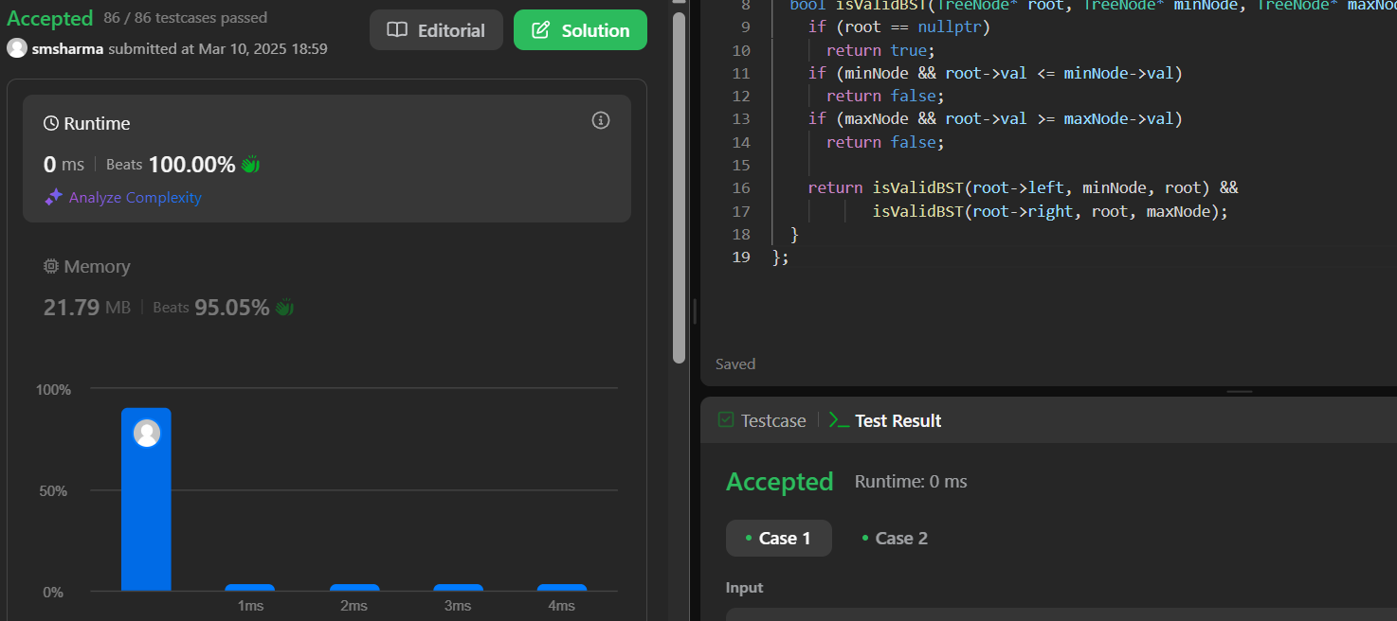

<https://leetcode.com/problems/symmetric-tree/submissions/1569127202/>

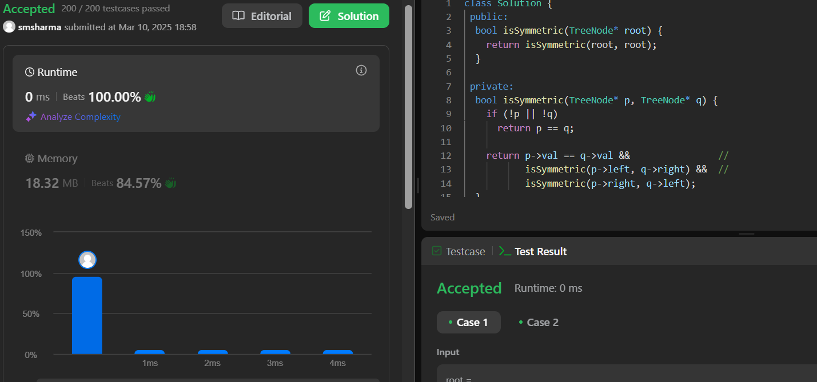

<https://leetcode.com/problems/binary-tree-zigzag-level-order-traversal/submissions/1569126585/>

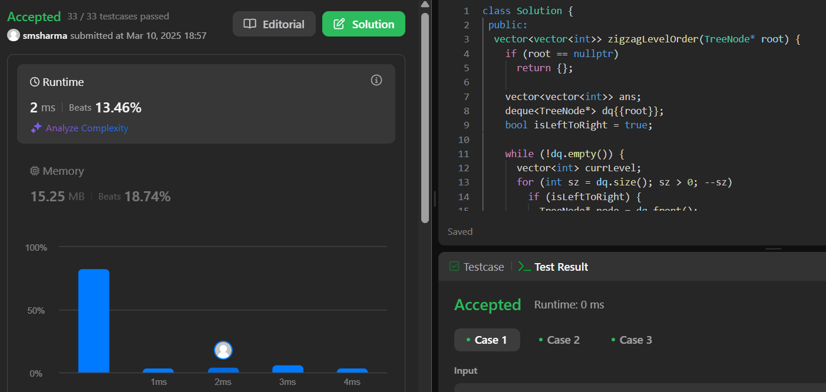

<https://leetcode.com/problems/lowest-common-ancestor-of-a-binary-tree/submissions/1569126125/>

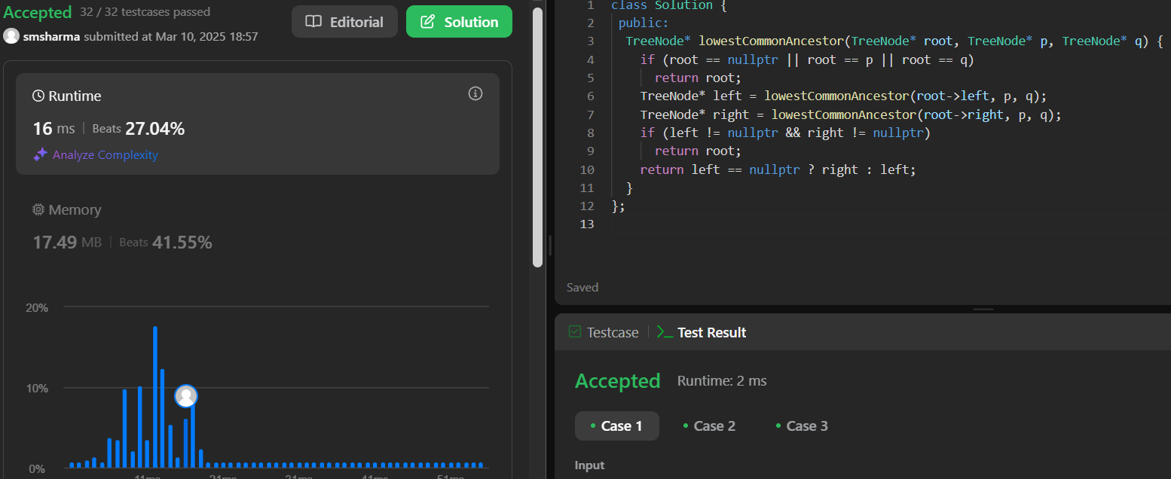

<https://leetcode.com/problems/binary-tree-inorder-traversal/submissions/1569125478/>

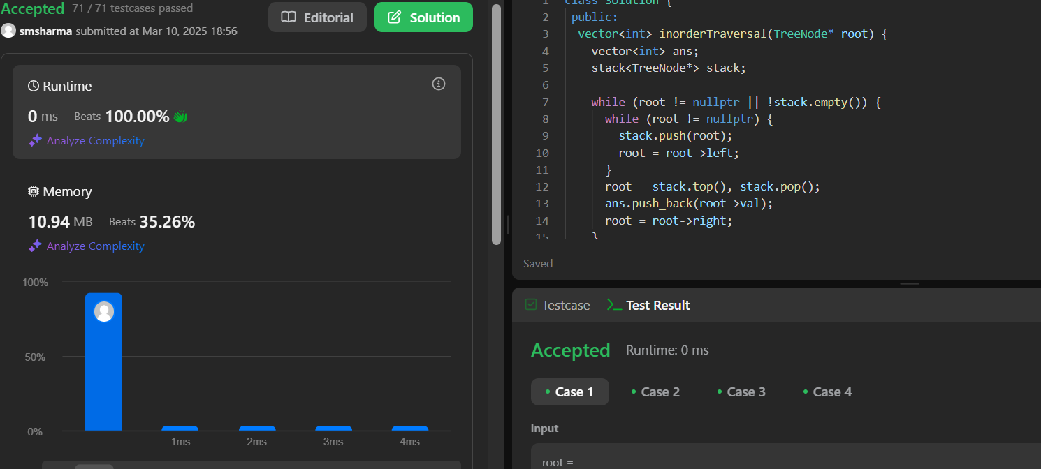

<https://leetcode.com/problems/binary-tree-level-order-traversal/submissions/1569124998/>

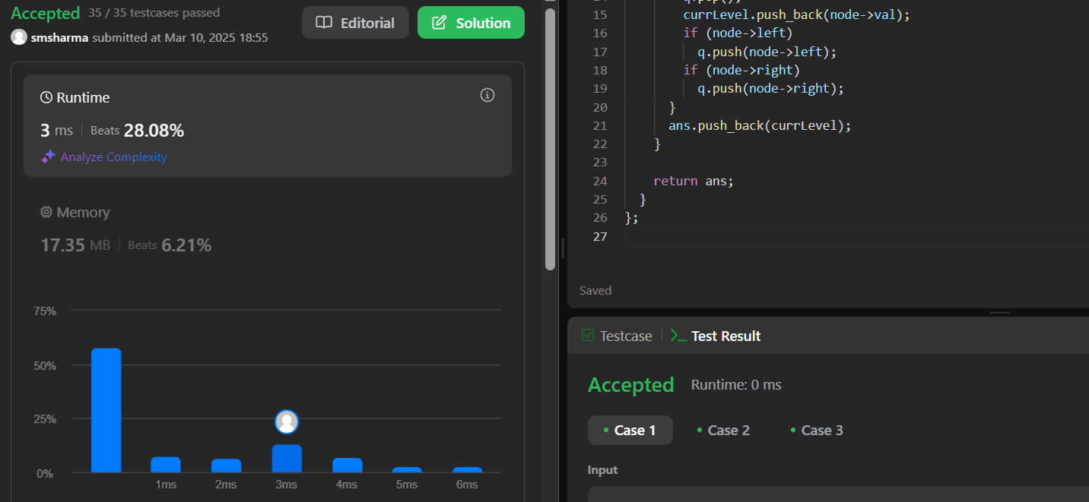

<https://leetcode.com/problems/maximum-depth-of-binary-tree/>

